PRACTICAL-7
AIM:
Wap to create a string like, “Hello World” and perform some operations.
- To perform all indexing / slicing operations.
- To perform update operation in string.
- To perform upper case and lower case operations.
- To perform delete operations.

CODE:
#Creating the string
text = "Hello World"
# Indexing / Slicing operations
print("Indexing Operations:")
print("First character:", text[0])
print("Last character:", text[-1])
print("Characters from index 0 to 4:", text[0:5])
print("Characters from index 6 to end:", text[6:])
#Update operation in string
updatedtext = text[:6] + "Universe"
print("\nUpdated Text:", updatedtext)
#Upper case and lower case operations
print("Upper case:", text.upper())
print("Lower case:", text.lower())
# Delete operations
text_after_delete = text.replace("World", "")
print("\nAfter deleting 'World':", text_after_delete)
OUTPUT:
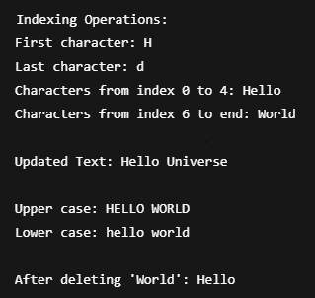
PRACTICAL-8
AIM:
Wap to create the list like [1,2,3, “Rohit”,”Ankit”,True] and perform some operations.
- To perform all indexing/slicing operations in above list.
- To perform all update operations in above list.
- To perform all Delete operation in above list.
- To perform all reverse operations in above list.

CODE:
# Creating the list
my_list = [1, 2, 3, "Rohit", "Ankit", True]
# (A) Indexing / Slicing operations
print("Indexing Operations:")
print("First element:", my_list[0])
print("Last element:", my_list[-1])
print("Elements from index 1 to 3:", my_list[1:4])
print("Elements from index 2 to the end:", my_list[2:])
# (B) Update operations in the list
print("\nUpdate Operations:")
my_list[1] = 10
my_list[5] = False
print("Updated List:", my_list)
# (C) Delete operations in the list
print("\nDelete Operations:")
del my_list[2]
print("List after deletion at index 2:", my_list)
my_list.remove("Rohit")
print("List after removing 'Rohit':", my_list)
my_list.pop()
print("List after popping the last element:", my_list)
# (D) Reverse operations on the list
print("\nReverse Operations:")
my_list.reverse()
print("Reversed List:", my_list)

OUTPUT:
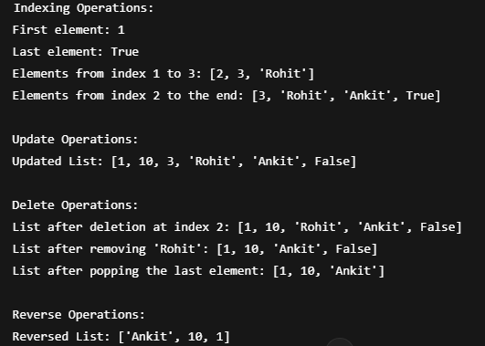

PRACTICAL-9
AIM:
Wap to Perform the Sum, Len, Avg, Min, Max Method in the list.

CODE:
# Creating the list
my_list = [1, 2, 3, 4, 5]
# (A) Sum of the list
sum_of_list = sum(my_list)
print("Sum of the list:", sum_of_list)
# (B) Length of the list
len_of_list = len(my_list)
print("Length of the list:", len_of_list)
# (C) Average of the list
avg_of_list = sum_of_list / len_of_list
print("Average of the list:", avg_of_list)
# (D) Minimum value in the list
min_of_list = min(my_list)
print("Minimum value in the list:", min_of_list)
# (E) Maximum value in the list
max_of_list = max(my_list)
print("Maximum value in the list:", max_of_list)
OUTPUT:
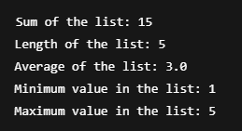

PRACTICAL-10
AIM:
Wap to perform all possible Operations in Tuple.

CODE:
tuple1 = (1, 2, 3, 4, 5)
tuple2 = ('a', 'b', 'c')

#Access elements by index
print("Accessing elements by index:")
print("First element of tuple1:", tuple1[0])
print("Last element of tuple2:", tuple2[-1])

#Slice a tuple
print("\nSlicing a tuple:")
print("Slice from index 1 to 3 of tuple1:", tuple1[1:4])
print("Slice of all elements in tuple2:", tuple2[:])

#Concatenate two tuples
print("\nConcatenating tuples:")
tuple3 = tuple1 + tuple2
print("Concatenated tuple:", tuple3)

#Repeat a tuple
print("\nRepeating a tuple:")
tuple4 = tuple1 * 2
print("Repeated tuple1:", tuple4)

#Get length of a tuple
print("\nLength of tuple1:", len(tuple1))
print("Length of tuple2:", len(tuple2))

OUTPUT:
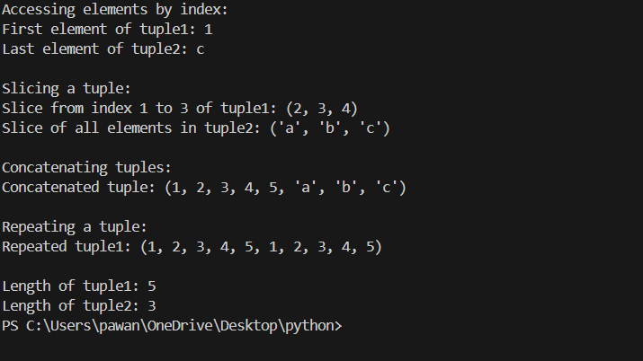

PRACTICAL-11
AIM:
Wap to Perform all possible Operations in Dictionary.

CODE:
dict1 = {'name': 'John', 'age': 25, 'city': 'New York'}
dict2 = {'course': 'Python', 'duration': '3 months'}
# Access values using keys
print("Name:", dict1['name'])
# Add a new key-value pair
dict1['email'] = 'john@example.com'
print("Updated dict1:", dict1)
# Modify an existing key's value
dict1['age'] = 26
print("Updated dict1 with modified age:", dict1)
# using `del`
del dict1['city']
print("dict1 after removing 'city':", dict1)
# using `pop()`
removed_value = dict2.pop('duration')
print("Removed 'duration':", removed_value)
print("Updated dict2:", dict2)
# Get the value of a key using `get()`
print("Get value of 'age':", dict1.get('age'))
print("Get value of 'email':", dict1.get('email'))
# Get all keys or values using `keys()` and `values()`
print("Keys of dict1:", dict1.keys())
print("Values of dict1:", dict1.values())
# length of a dictionary
print("Length of dict1:", len(dict1))
# Clear all items from the dictionary
dict1.clear()
print("dict1 after clearing all items:", dict1)

OUTPUT:
